# SOLANCO HIGH SCHOOL SUMMER REVIEW PACKET

For students entering ***Advanced Trig/Intro to Calculus***

The math department at Solanco High School wants you to be successful in Advanced Trigonometry and Intro to Calculus (ATC). This course is a demanding course that will expand on the concepts from your previous math courses. There are a number of Algebra topics that you should be familiar with in order to be successful. This packet is designed to help you review the necessary skills.

Included with each topic is a brief review. If you find that you still need additional help, I would suggest the following websites:

* Purplemath.com
* Khanacademy.org
* Wolframalpha.com

Be sure to follow the key information below when completing this packet:

* **The packet is due the day you return to school in August**
* Every problem must be completed/attempted.
* **If completed by the first day of school, you will receive 10 points extra credit**.
* **Work must be shown to receive credit.**
* Final answers must be circled.
* When you return in August, your teacher will review the packet and give you the opportunity to ask questions.
* A quiz covering the material from the packet will be given at the end of the first week of school.

We hope that you have an enjoyable summer and return to school ready to be successful in Advanced Trig/Intro to Calculus!

**Linear Equations and Inequalities:**

**Solve each equation.**

1. 3x – 4 = 8 2. 4 – 2x = 3x – 6 3. 2(3 – 4x) – 5(2x + 3) = x – 17

4.  5.  6. 

**Solve each inequality.**

7. 3x – 1 ≥ 6x + 8 8. -1 < 3x – 2 < 7 9. 

10. Solve for x in  11. Solve for x in 

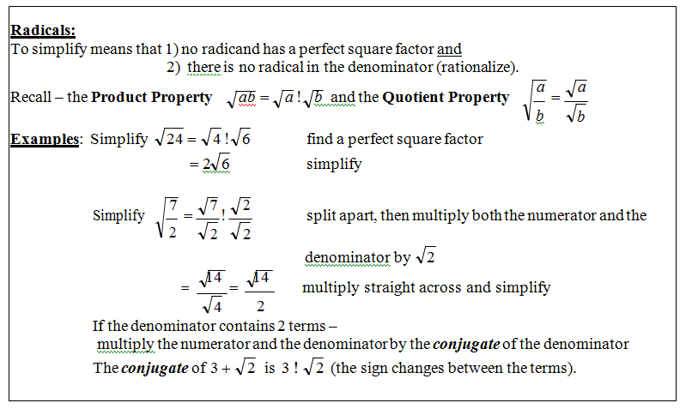

–

•

•

•

**Simplify each of the following.**

1. ** 2.  3.  4. **

5.  6. 

**Rationalize.**

**7.  8. **

**Equations of Lines:**

**Slope intercept form: y = mx + b Vertical Line: x = c (slope is undefined)**

**Point-Slope Form: y – y1 = m(x – x1) Horizontal Line: y = c (slope is 0)**

**Standard Form: Ax + By = C Slope: **

* 1. State the slope and y-intercept of the linear equation: 5x – 4y = 8.
  2. Find the x-intercept and y-intercept of the equation: 2x – y = 5
  3. Write the equation in standard form: y = 7x – 5

**Write the equation of the line in slope-intercept form with the following conditions:**

* 1. Slope = -5 and passes through the point (-3, -8)
  2. Passes through the point (4,3 ) and (7, -2)
  3. x-intercept = 3 and y-intercept = 2

**Graphing:**

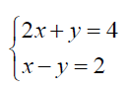**Graph each function, inequality or system.**

1. 3x – 4y = 12 2.

 

3. y < -4x – 2 4. y + 2 = |x + 1|

 

 5. y > |x| - 1 6. y + 4 = (x – 1)2



**Systems of Equations:**

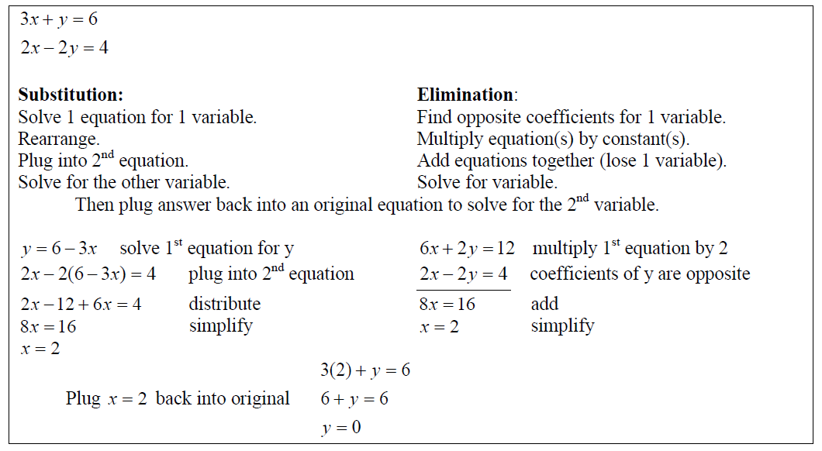

**Solve each system of equation. Use any method.**

1. 2x + y = 4 2. 2x + y = 4

3x + 2y = 1 3x – y = 14

1. 2w – 5z = 13

6w + 3z = 10

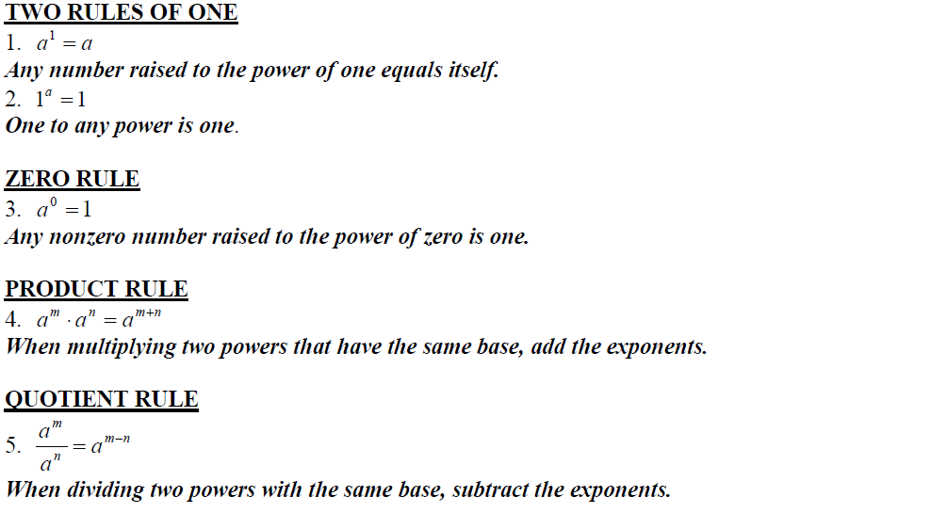

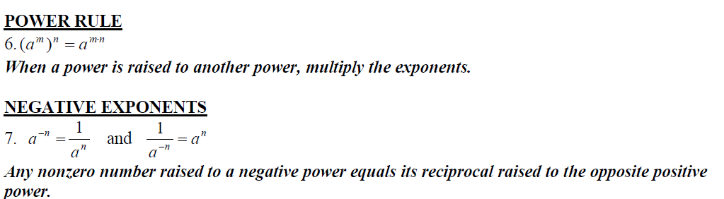

**Express each of the following in simplest form. Answers should not have any negative exponents.**

1. 5a0 2.  3.  4. 

**Simplify.**

1. (3m2)(2m) 5. (a3)2 6. (-b3c4)2 7. 4m(3a2m)

**Polynomials:**

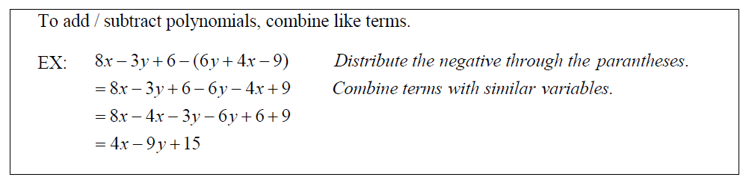

**Simplify.**

1. 3x3 + 9 + 7x2 – x3 2. 7m – 6 – (2m + 5)

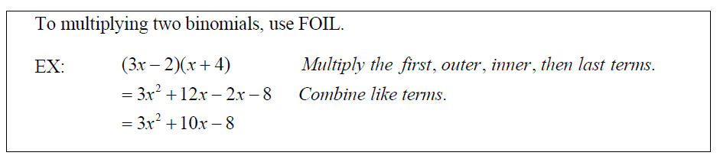

**Multiply.**

1. (3x + 1)(x – 2) 4. (x + 3)(x – 3)
2. (x – 5)2 6. (5x + 7y)(5x – 7y)

**Factoring:**

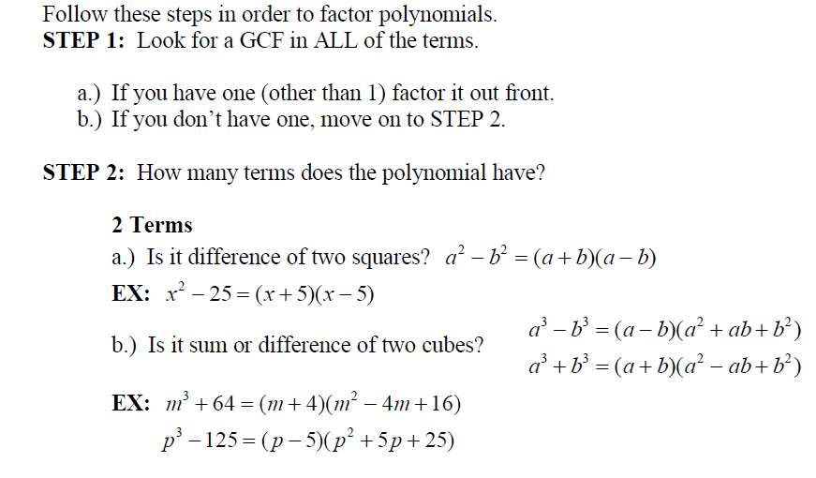

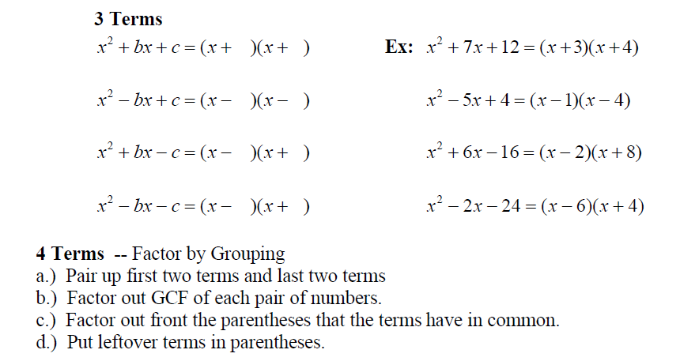

**Factor completely.**

1. x2 + 4x – 12 2. 6 – 5x – x2 3. 2x2 + 2x – 60
2. 9x2 – 5 5. 27x3 – 8 6. 2mn – 2mt + 2sn – 2 st

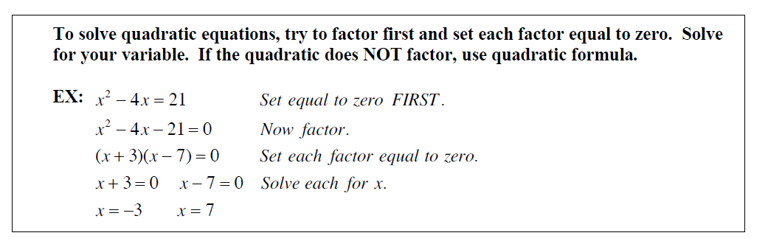

**Solve each equation:**

1. x2 – 4x – 12 = 0 2. x2 + 25 = 10x 3. x2 – 14x + 40 = 0

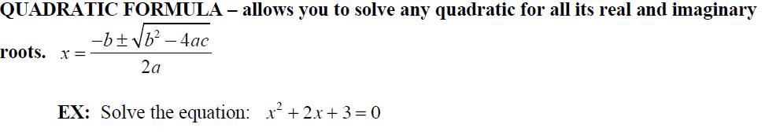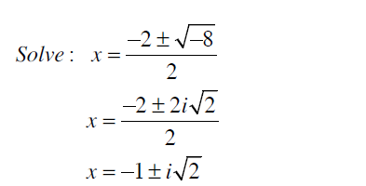

**Solve each equation.**

1. x2 – 9x + 14 = 0 5. 5x2 – 2x + 4 = 0

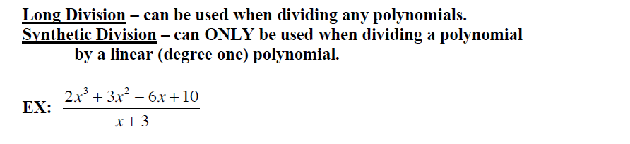

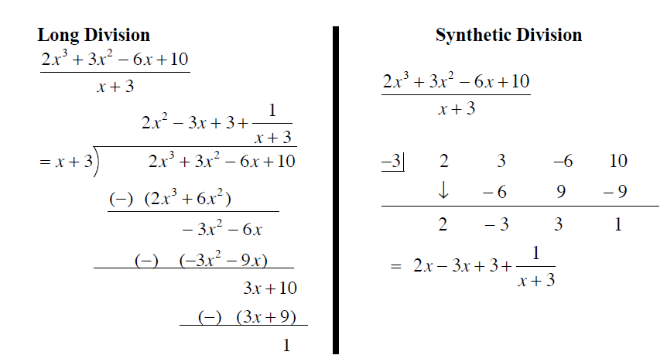

**Divide each polynomial using long division OR synthetic division.**

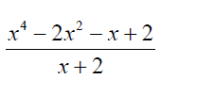

1. 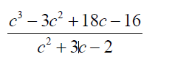 2.

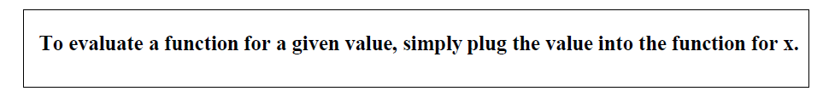

**Evaluate f(x) = x2 – 6x + 2, for the given value.**

1. f(3) 3. f(x + 2) 4. f(x + h)

**Rational Expressions:**

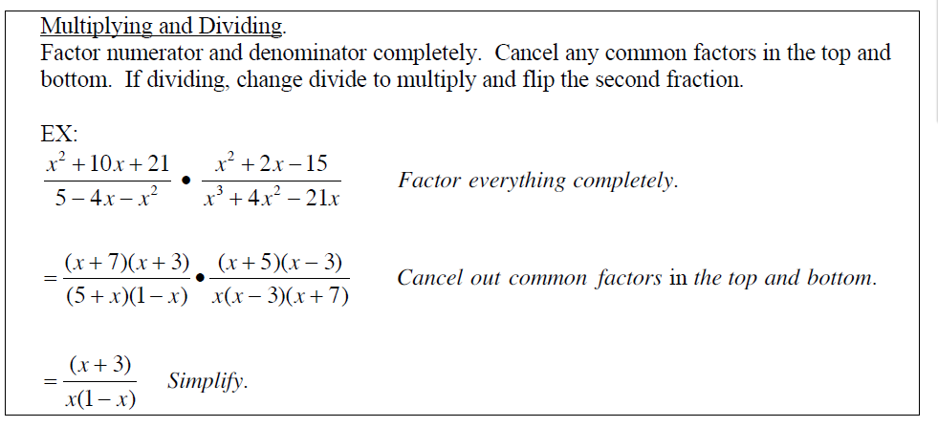

**Simplify.**

1.  2.  3. 

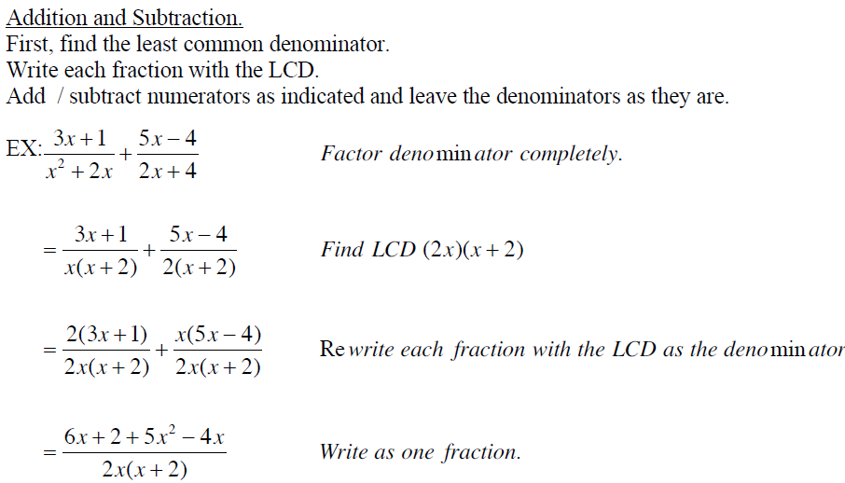

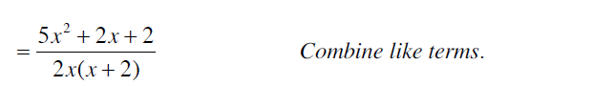

1.  2.  3. 

**Solving Rational Equations**

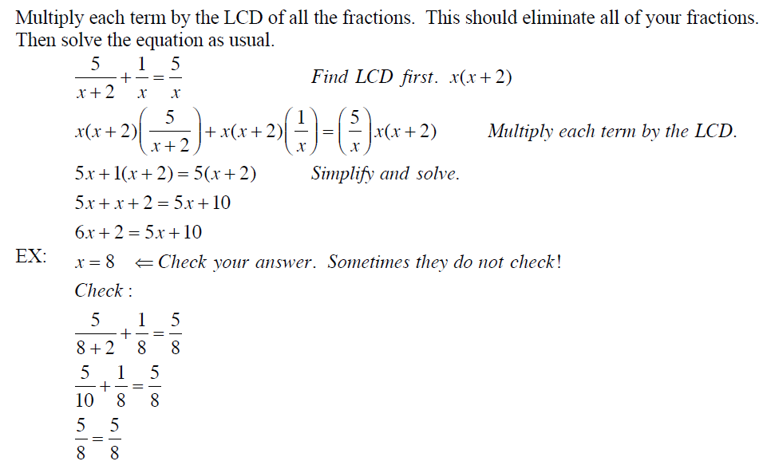

**Solve each equation. Check your solutions.**

1.  2.  3. 