A.P. Chem. Summer Assignment Name: _________________________
The nature of this course makes it imperative that you complete summer work. All of this material is information already covered in Advanced Chemistry. We will spend a lot of time problem-solving in class, but YOU must also put in time outside the class. We will also be completing numerous college-level labs.
Textbook: Chemistry-Zumdahl 9th ed.
When reading you should make notes or an outline/develop questions that you might have.
Read Chapter 1—pp. 1-31 and watch the videos on Schoology
Do questions: #2,3,8,16,20,23,25,27,29,31,33,37,39,41,45,47,55,59,61,65,71,73,75,81,83,87,89,101,115
Write out the answers—SHOW WORK—you can check some answers in the back of the book for the odd problems
Read Chapter 2---pp.42-72 and watch the videos on Schoology
Do Questions: #6,12,13,15,19,23,25,27,29,31,33,37,45,55,57,59,61,65,75,79,83,85,87,89,93,101,115,121
Read Chapter 3---pp.81 to 124 and watch the videos on Schoology
Do Questions: #8,10,11,18,19,21,23,25,27,31,32,33,35,37,39,41,51,53,55,57,61,63,67,71,75,77,81,85,89,93, 97, 99,101,107,109,115,121,125,127,131,143, 145,149,163,181
When you return, we will be quickly reviewing Ch. 1-3, with special emphasis on the last part of chapter 3.
You should also read over chapters 4-7 and watch the videos on Schoology. These chapters are also a review of what you studied in Advanced Chemistry--reactions/gases/thermochemistry/atomic structure and periodicity
I WELCOME AND EXPECT QUESTIONS—PLEASE WORK WITH SOMEONE ELSE IN THE CLASS AND PLEASE EMAIL ME WITH QUESTIONS OR SEND ME A MESSAGE ON REMIND---***
Please submit the images of your assignments to Schoology as you finish them. There are suggested deadlines and minimum scores you must earn to move through the Schoology course. All assignments must be uploaded to Schoology BEFORE the first day of school. Please join the class. Access code 7TF8C-HBP9N
You can email questions or concerns to at: jessica_tipping@solancosd.org and see the back of this paper for Remind sign up information.

Sign up for important updates from Mrs. Tipping.
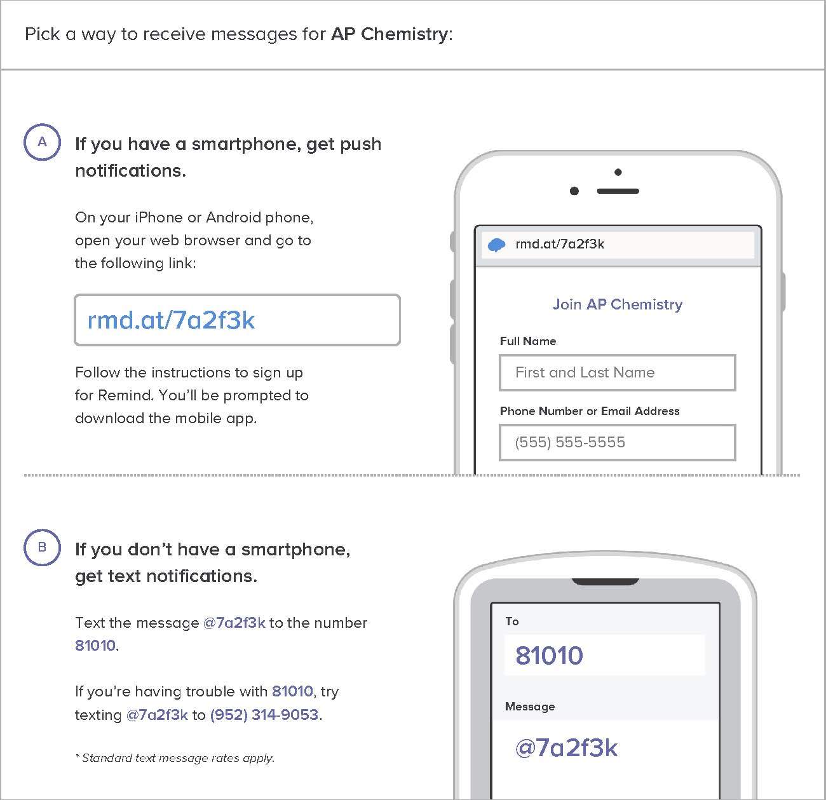
Don’t have a mobile phone? Go to rmd.at/7a2f3k on a desktop computer to sign up for email notifications.

