Summer Program | Where & Who | When | Information | Deadline
Reading Skills and Speed Reading Summer Programs | Temple University  Ages 4 years old to Adult | Different Sessions for ages 4 years old to Adults | Find more information and application in the summer program file | Varies by Sessions
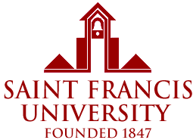  Health Career Awareness Camp | St. Frances University  High School Students  Camp is limited to 20 Students | July 9th to  July 14th | Find more information and application in the summer program file | May 5,  2017
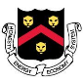  Wentworth Institude of Technology  summerFAB | High School Students  Entering 10th grade | July 1th to  August 4th | Find more information and application in the summer program file | April 1,  2017
The Bridge: College Prep & Leadership Academy | University of Pittsburgh  High School Students | July 9-14, 2017 | Find more information and application in the summer program file | Until Full
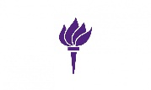  NYU School of Professional Studies  2017 HS Academy Career Edge Program | NYU  High School Students | Session 1  7/10-7/14  Session 2  7/17-7/21  Session 3  7/24-7/28  Session 4  7/31-8/4 | Find more information and application in the summer program file | Residential  June 1, 2017  Commuter  July 1, 2017
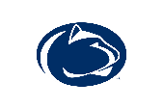  Penn State Summer Discovery | Penn State  High School Students completing 9th-12th | 3 weeks  6/25/17-7/14/17  2 weeks  7/16/17-7/29/17 | Find more information and application in the summer program file | Until Full
Temple University Summer Owls Leadership Experience | Grade 11th and 12th in 2017-2018  Temple University | July 10th-July 28th, 2017 | Find more information and application in the summer program file | $55 Application Fee waived until March 18, 2017
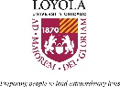  Advanced Leadership Academy (Hoby) | Loyola University Chicago | July 6th-11th,  2017 | Find more information and application in the summer program file | Until Full
GW Pre College 2017 | The George Washington University  Current  High School Students | Different sessions  (on flyer) | Find more information and application in the summer program file | US University Prep-March 1,  2017  Summer Immersion-May 1, 2017
Summer Experience  Camp | Washington University in St. Louis  Current Middle &  High School Students | Different sessions  (on flyer) | Find more information and application in the summer program file | April 1,  2017
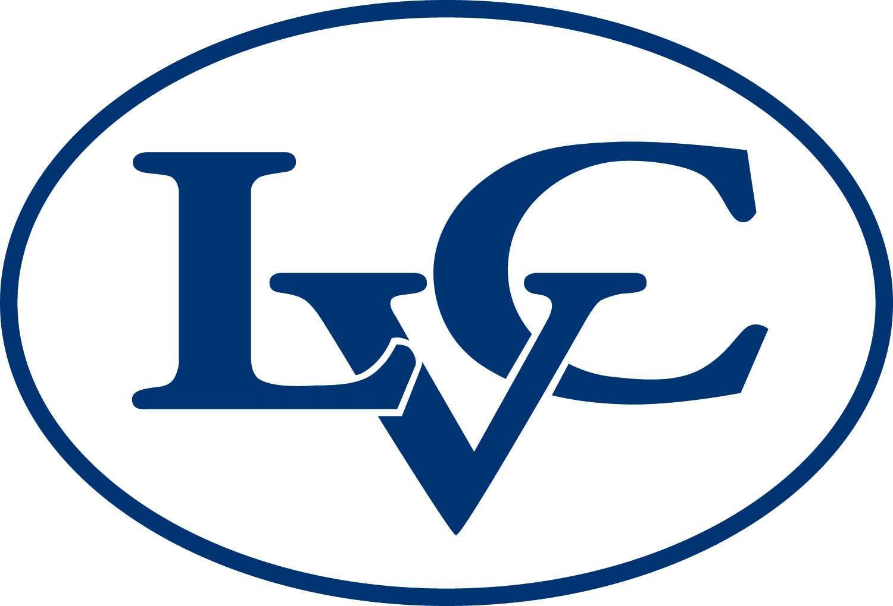  Health And Biomedical Sciences Summer Camp | Lebanon Valley College  Current  High School Students | June 25th-30th or July 23rd-28th 2017 | Find more information and application in the summer program file | Until Full
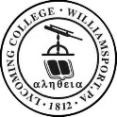Pennsylvania Free Enterprise  Week | Lycoming College  Last Session at Lycoming College or Penn College  Current  Sophomore/Junior | Week 1 - July 2-8 (Lycoming College)  Week 2 - July 9-15 (Lycoming College)  Week 3 - July 23-29 (Lycoming College)  Week 4 - July 30 - Aug. 5 (Lycoming or PCT) | Find more information and application in the summer program file | Early Application March 3, 2017  Final Application April 7, 2017

